caerwent Community centre, COVID-19 Operational plan
For the safe use of the building and agreement
for hire. Version 5 26/11/2020
Reviewed 26/10/2021
Final Draft
Table of Contents

A message from Caerwent Community Centre (CCC) 1
Key Documents: 2
Document control 2
Documentation review and updates 2
- Background 3
1.1 Coronavirus (COVID-19) 3
1.2 Welsh Government mandated control measures 4
2.0 Responsibilities 4
2.1 Group management 4
2.2 Those entering the building 5
3.0 General arrangements for your safety 5
3.2 Cleaning arrangements for the building 6
3.3 Toilet facilities 7
3.4 Hand washing and hygiene facilities 8
Ahead of any group arrival 8
3.6 Emergency arrangements and procedures 9
3.7 Social distancing 9
  - Arrangements prior to persons arriving 10
4.1 Attendees 10
4.2 Travelling and parking at the Centre 11
4.3 Entering and exiting the building 11
4.4 Contact tracing 11
5.0 The application and maintenance of these measures 11
5.1 Application 12
5.2 External hires 12
5.3 Review and updates to documentation 12
6.0 References 12

A message from Caerwent Community Centre (CCC)
Thank you for reading this document outlining how we at CCC seek to manage the threat of COVID-19 and re-open the centre for use once more.
As a community based organisation we are looking towards the future and the possibility of opening the centre for limited use; subject to monitoring and further guidance. We appreciate that user groups will be keen to get back into the building, but it is paramount that together, we do all we can to protect those using the facility from the threat of COVID-19.
This document is the means by which we lay out our immediate plans for reopening, and also lay out the expectations of compliance required by those wishing to use the centre.
Finally, this is a document that will be under frequent review. We would ask for your suggestions in the coming days in how to improve this document to fit our needs as a Community centre.

Key Documents:
- Welsh Government, 8/1/2021. “Coronavirus (COVID-19) social distancing guidance for everyone in Wales”. Available at: https://gov.wales/coronavirus-social-distancing-guidance [Accessed 26/10/21]
- Welsh Government, Safe use of Multi-purpose community centres. 26/10/2021 Available at: https://gov.wales/safe-use-multi-purpose-community-centres-covid-19
- Gov.UK, 15th May 2020. “COVID-19: cleaning in non-healthcare settings”. Available at: https://www.gov.uk/government/publications/covid-19-decontamination-in-non-healthcare-settings/covid-19-decontamination-in-non-healthcare-settings [Accessed 26/10/21]

Document control
Authorised By: | Caerwent Community Centre Ltd
Document Title | Caerwent Community Centre, COVID Operations Policy
Version: 5 | Date written: 24th Sept. 2020. Latest Review 26/10/2021
Document Owner: | CCC Ltd Mark Lewis designated committee member

Documentation review and updates
This document shall be reviewed Monthly and as Government policy changes dictate. The arrangements and their effective outcomes will be monitored and reviewed periodically to help ensure a current and efficient course of operational and risk management. This Policy should be read in conjunction with the existing and additional risk assessments in place at Caerwent Community Centre, along with government guidance and advice.
Review | Reviewed By: | Date of Next review:
26/11/2020 _ 8/1/2021 26/10/2021 | Mark Lewis | May 2022.
Document scope
This document is the means by which Caerwent Community Centre’ response to COVID-19 risk is disseminated. It seeks to lay out the updated policy changes and new arrangements by which the Centre seeks to re-engage in external events and for the phased return of normal activities. This document should be read by all those wishing to use the building for an approved reason, such as a group booking or meeting.
It outlines the mitigation and control measures put in place to safeguard the health, safety and wellbeing of all persons who enter the building. The measures laid out seek to prevent the transmission of COVID-19 on premises so far as is reasonably practicable.
The document and its control measures have been brought together by the CCC team, whom, using the most current information, government advice and the COVID risk assessment have sought to create an effective operational plan.
These measures cover the general opening and operation of the building here in Caerwent. They DO NOT COVER specific group activities, nor negate the obligation of each user group to complete COVID specific risk assessments and plans specifically for their meetings.

Background

1.1 Coronavirus (COVID-19)
Coronavirus disease (COVID-19) is an infectious disease caused by a newly discovered coronavirus¹.
COVID-19 spreads mainly through droplets of saliva or discharge from the nose when an infected person coughs or sneezes¹. These droplets may also be on the hands of an infected person and can thus also be spread when the individual touches and thereby contaminates a surface, e.g. a door handle or light switch².
The incubation period – time between catching COVID-19 and developing symptoms of the virus – ranges from 1 to 14 days².
The virus can be transmitted when people who are infected show symptoms such as coughing. There is also some evidence suggesting that transmission can occur from an infected person even two days before they show any symptoms³.
Infection with COVID-19 can result in many different symptoms, however the three key symptoms associated with this virus are as follows:
- A high temperature – this means you feel hot to touch on your chest or back (you do not need to measure your temperature)
- A new, continuous cough – this means coughing a lot for more than an hour, or 3 or more coughing episodes in 24 hours (if you usually have a cough, it may be worse than usual)
- A loss or change to your sense of smell or taste – this means you've noticed you cannot smell or taste anything, or things smell or taste different to normal⁴

1.2 Welsh Government mandated control measures
In order to reduce the spread of COVID-19 from one person to another, Welsh Government have advised that the following four actions are adhered to by all Welsh residents:
- Always observe social distancing (also known as physical distancing) – stay away from others, indoors and outdoors
- Wash your hands regularly
- Work from home if possible⁵
In order to protect those thought to be at high risk of severe illness if infected with COVID-19, Welsh Government have advised individuals with certain health conditions, those age 70 and over, and pregnant women to be stringent in following social distancing and good hand hygiene regulations⁵.
Welsh Government have also advised that individuals with symptoms of COVID-19 stay at home.
It is essential that attendees and incoming organisations adhere to these regulations. This document therefore outlines the measures that CCC will be taking in order to ensure that social distancing is maintained within the centre and that regular hand washing, or use of hand sanitiser if hand washing is not possible, is undertaken by centre attendees.
Amendment – September 2020 – Face Masks are now mandatory for all persons entering the building at Caerwent Community Centre, in line with Welsh Government legislation as of 14th September 2020.

2.0 Responsibilities

2.1 Group management
CCC as the organisation managing the building, has a responsibility to risk assess and manage the risk outcomes associated with COVID-19 within the facility and throughout its operations in general. The Centre and its management team will implement a number of different measures and systems of operation to enable safe use of the building within a structured timeframe. CCC will make decisions based on the latest Welsh Government guidelines when the team feels that the correct safety measures are in place.
CCC has a duty of care towards all volunteers and contractors visiting the building to, so far as is reasonably practicable, mitigate the risk of COVID-19 within its facilities. However, mitigation of risk largely depends upon those who choose to enter the building.
Each individual organisation or user group has a responsibility to safely plan their operations at the centre. This document does not cover hire group specific use.

2.2 Those entering the building
It is the responsibility of all persons entering the building to take reasonable measures to ensure their own health, safety and well-being in addition to that of those around them. In order to do this, it is required that all individuals entering CCC building comply with Welsh Government COVID-19 guidance plus the control measures instigated by the organisation.
As individuals, we all have a duty to safeguard those around us from the threat of COVID-19. It is thus essential that all persons entering the building do so, firm in the knowledge that as far as they are aware, they have none of the key symptoms of COVID-19 (listed above) and are not required to self-isolate due to recent exposure to someone with a positive COVID-19 test result.

3.0 General arrangements for your safety
The following arrangements have been put in place for your safety, these are based on the latest Welsh Government information and taken from the findings of the specific COVID-19 risk assessment undertaken at the centre.
At the time of writing this revised guidance (26/10/21)Wales has now moved to Alert Level 0. See the Coronavirus Control Plan published by Welsh Government for information on the various alert levels.

Face Coverings.
It is still a legal requirement to wear face coverings in all public spaces. Except where the person is aged ten or under or where the person has a reasonable excuse not to wear a face covering, or if they temporarily need to remove it for the reasons outlined below.
A community centre is identified as a premise in which, a person must wear a face covering. Hire groups may have some questions about the use of face coverings, the following information may be of assistance.
A reasonable excuse not to wear a face covering is defined as, the person:
- is not able to put on or to wear a face covering because of a physical or mental illness, or because of a disability or impairment;
- is accompanying somebody who relies on lip reading where they need to communicate; or
- is escaping from a threat or danger and doesn’t have a face covering.
- Face coverings should be worn at all times, and they must be worn correctly. However, the individual may have a reasonable excuse to temporarily remove the covering and some examples are as follows:
- to take medication
- to eat or drink
- to avoid harm or injury, either to the individual themselves or to others, such as alerting another individual to danger
If using a face covering or mask, you must not take it off and leave it on surfaces and you must not leave a face covering/mask below your nose or hanging off your chin. It is important that you are aware of how to wear and care for your face covering safely, see here for guidance from Welsh Government.
There are a limited number of cases where face coverings will not be required. For example, when you are seated to eat or drink. Face coverings must be worn when entering the premises and while waiting to be served at a counter (if applicable, for example) or to be seated; they must also be worn when moving around, such as when going to toilets or when leaving. Another example is if you are exercising. However, if you are preparing to exercise, changing or undertaking any activity that isn’t strenuous, especially when in close contact with other people, you will need to wear a face covering.

3.1 Building layout and zoning;
The building, as part of the risk assessment process will be spilt into zones. The objective of this is to enable safe movement of all persons, both visiting and working within the building.
NB. Capacities are determined by the size of the room, social distancing guidelines and the means of safe access and egress.
The three zone types are as follows:
Green zones: Areas that have been assessed as communal gathering areas. These areas will be specifically organised for communal gatherings with social distancing measures, cleaning regimes and regular monitoring by the hirers staff.
Green Zone
Sports Hall
Community Room
Meeting Room

Amber zones: These are areas of thoroughfare or flow / access points, stairways. Means of getting to green zone areas. Standing or gathering is prohibited in these areas
I.e, corridors, toilet access points, hallways

Red Zones - No access at all to these areas apart from CCC committee members and those approved by them (namely leaders of hire groups and there appointed stewards)This is to ensure safe access and working environments for staff and to reduce the workload of the facilities and cleaning team.

3.2 Cleaning arrangements for the building
Guidance has been taken from the government guidance. Cleaning In non-healthcare settings May 2020⁶
A specific cleaning schedule and control document has been drawn up separately.
Green zones should be cleaned after every use. Particular attention will be paid to surfaces that are likely to be touched by attendees such as doors, particularly door handles, seat arms and backs, and tables. Any scheduling of centre use should take into account appropriate cleaning times.
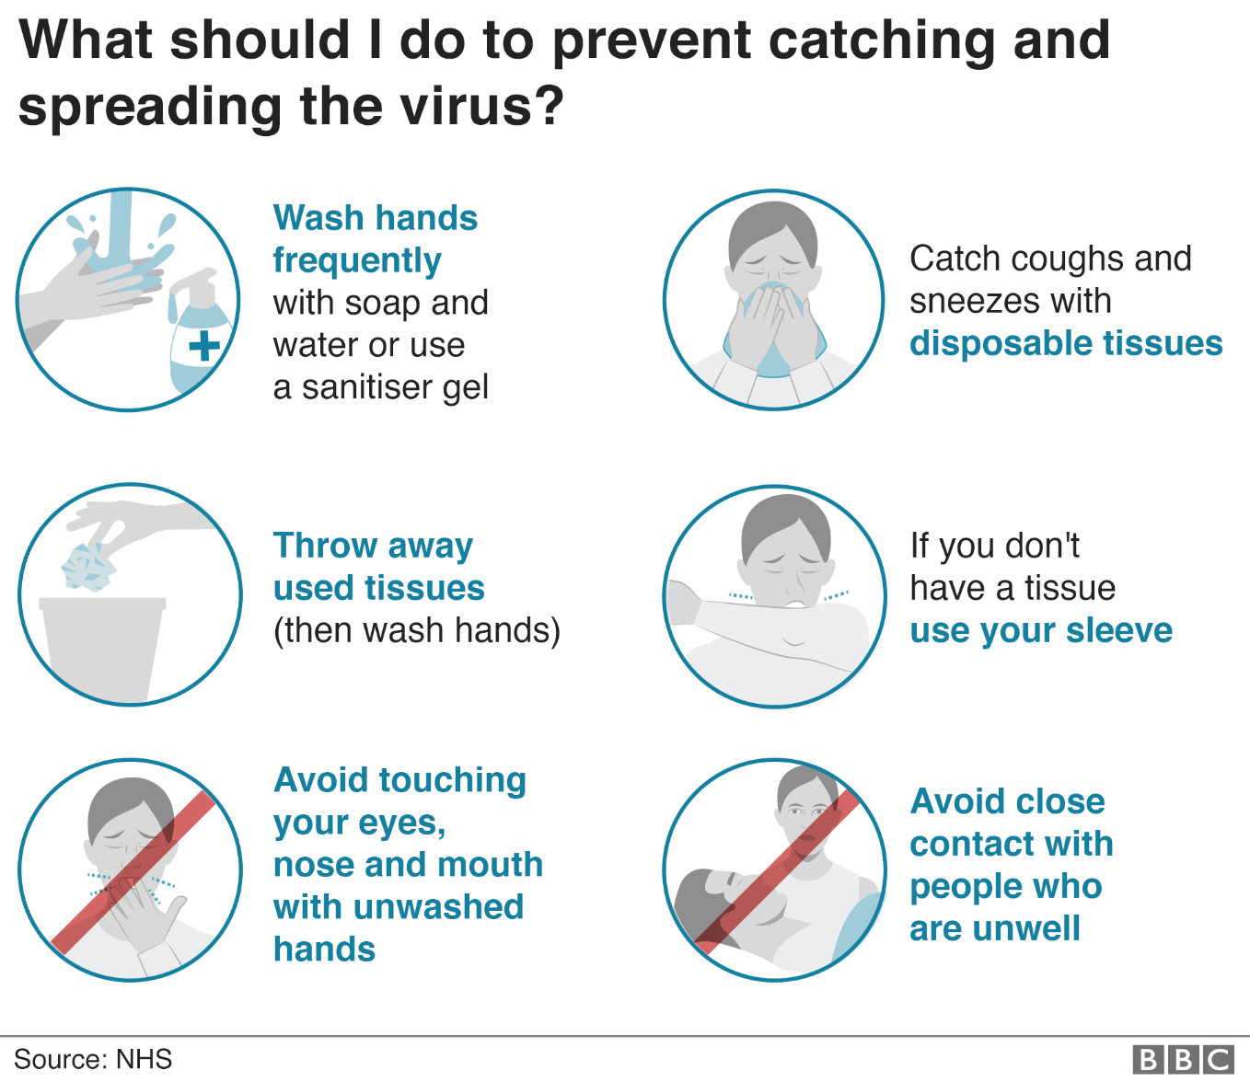
Cleaning regimes will be enhanced for busy areas including amber zones, with an emphasis on surfaces that will be touched consistently; including door handles, light switches, etc.
Within red zones, frequent cleaning of work areas and equipment in between use is recommended. Usual cleaning products can be used for this. Antibacterial wipes can also be used to clean catering equipment, technical equipment etc.
There should be adequate waste management for the disposal of an increased amount of cleaning products.
Ventilation in all areas is key to help prevent the transmission of COVID-19 so windows and doors will be kept open where possible. However, fire doors should not be propped open to aide this.
NB. If cleaning is required after a known or suspected case of COVID-19 then specific guidance should be referred to⁷.

3.3 Toilet facilities
Advice and control measures taken from Welsh Government Guidance – Providing safer toilets for public use: coronavirus – 2nd July 2020
Clear use and cleaning guidance shall be provided for toilet facilities.
As activities within the near future are planned to be kept short, we request that you avoid using the toilet facilities if possible. If this is not possible then there will be toilet facilities available, but their use will be restricted as follows:
- A one in, one out policy will be instigated to ensure social distancing is possible within the toilet facilities. This does not apply to members of the same household.
- Urinals may be blocked off to prohibit their use. Cubicles are preferred due to the enclosed nature of the facility.
- There should be plentiful supply of hand drying facilities.
- Individuals will be expected to apply alcohol gel to their hands when leaving the toilet facilities.
- The main entrance to toilet doors will be wedged open to prevent individuals touching the doors or handles.
- An increase in waste capacity for paper towels may be required.
- Toilet cleaning regimes are to be enhanced.

3.4 Hand washing and hygiene facilities
In addition to the existing hand wash facilities within the toilets of the building, a number of hand sanitising stations have been installed. These will be located at green zone entry points, as well as in hallways. These will be monitored and replenished as required.
Individuals will be expected to apply alcohol gel to their hands on entering the building, after using the toilet facilities and before moving to another zone.
Signage and infographics have been installed to build awareness of good hand washing technique, the need to increase washing and to avoid touching your face, along with the advice to cough or sneeze into a tissue, then bin it immediately.

3.5 Group specific arrangements
It is the responsibility of each user to plan how their meeting will work. Having procedures and safety protocols in place for their time at the centre and the planning of their meeting. Everything from sign up, arrival, activities and leaving the building. Groups should also review their activities on a frequent basis to ensure compliance and best practice.
Organisers should seek guidance and best practice that is most appropriate for their group or activity.

Ahead of any group arrival
A) Attendance to the meeting must be coordinated, perhaps permitted through a sign-up process. This is important because the number of persons in the centre at any one time should be limited in order to comply with social distancing regulations. Those hiring the facility are also required to document the contact details of everyone attending the building in order to feed into the national track and trace facility – see section 4.4 for more details.
B) Seating and equipment arrangements should be specifically rearranged to enable a safe environment for all those attending. Please understand that some areas within the centre will be closed off for the time being.
C) Attendees may be asked to arrive at the centre within certain time slots prior to start time in order to help avoid congestion at the centre entrance.
D) We appreciate that social distancing is a difficult concept for children to understand. Therefore, we ask that parent/carers take particular care to ensure that their children adhere to social distancing whilst in the building.
E) Every user group must have their own Covid risk assessment and operation plan that indicates how they will safely undertake their meetings. These plans must be sent into CCC before access will be granted.
F) Every user group must provide their own Hand Sanitiser for use throughout their meeting or activities. Hand sanitiser will only be provided in the entrance corridor and at the toilet facilities.

3.6 Emergency arrangements and procedures
Largely the emergency arrangements and procedures will remain the same for the building. Due to the decrease in number of persons, specific measures and routes may be advised to reduce the risk of contact with multiple persons. Any changes, should they be required will be disseminated accordingly. However, in an emergency, preservation of life takes priority and all persons should vacate the building via the nearest and safest route.

3.7 Social distancing
At all times, the individual has the responsibility to abide by Welsh Government guidance on social distancing measures⁴. The specific requirement to maintain two metre distancing has been removed. Whilst, it is no longer a legal requirement, it is an effective measure and perhaps one of the easiest and most obvious measures to take.Signage will be installed around the building to remind all attendees of the need to comply with this guidance.

The following arrangement have been instigated by CCC in order to comply with current social distancing regulations:
- Specified entrances and exits
- Specified walking routes
- Zone segregation – Green, Amber, Red
- Social distancing signage
- A one in one out system when using the toilet facilities
Group leaders should be monitoring compliance with social distancing guidelines.

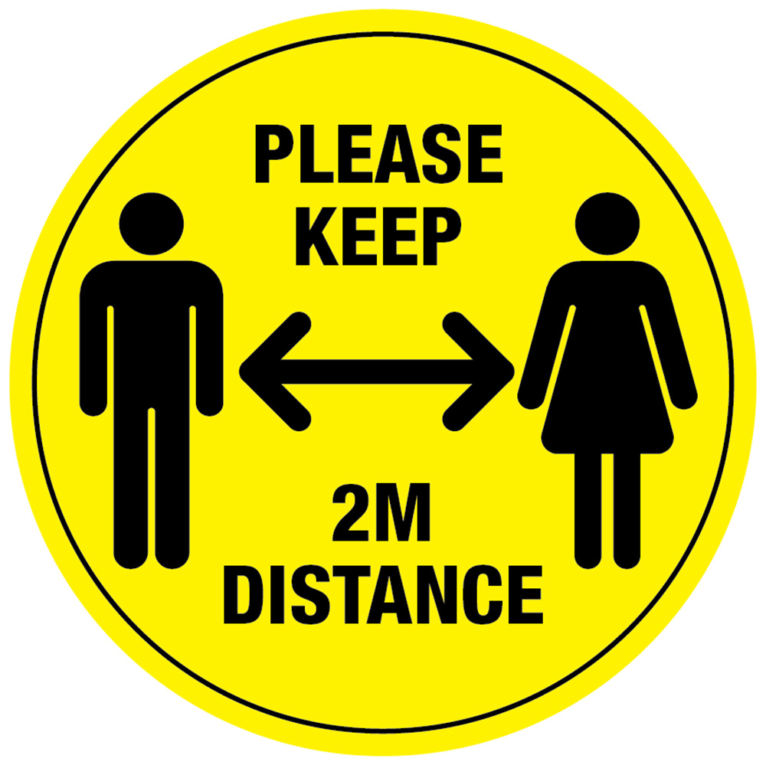

Arrangements prior to persons arriving

4.1 Attendees
As mentioned above, it is the responsibility of each person wishing to enter the building at CCC to declare themselves, so far as they can, free from the following symptoms of COVID-19
A high temperature – this means you feel hot to touch on your chest or back (you do not need to measure your temperature)
A new, continuous cough – this means coughing a lot for more than an hour, or 3 or more coughing episodes in 24 hours (if you usually have a cough, it may be worse than usual)
A loss or change to your sense of smell or taste – this means you've noticed you cannot smell or taste anything, or things smell or taste different to normal⁴
No person who has been advised to shield, self-isolate (due to potential COVID-19 symptoms, a positive COVID-19 test, or is a contact of someone with a positive COVID-19 test), has been placed into quarantine, or deemed by the NHS as ‘High Risk’ should attempt to enter or travel to the centre.
The user group is responsible for organising those attending its meetings.

4.2 Travelling and parking at the Centre
All persons should travel via their own means where possible, or by using approved methods of transport. Parking arrangements remain the same as previously.
Please use care when parking and walking to and from the centre to ensure compliance with social distancing.

4.3 Entering and exiting the building
Dependent on the event or meeting taking place, different areas of the building and therefore access points could be utilised. Each Green Zone will have its own designate means of access and egress.
Entering the building may well take time and there may be queuing or waiting areas installed to allow for social distancing. These mechanisms should be signed and marked out. Each individual group should have their own sign in and monitoring mechanisms in operation.
Entrance and exit areas such as the main entrance hallway must be kept as clear as possible to allow a smooth flow during access and egress. These areas are designated AMBER zones.

4.4 Contact tracing
We are required to document the names and contact details of all individuals attending the centre. This is so that Public Health Wales is able to contact all those present at a particular event within the centre, should someone who attended that event test positive for COVID-19.
Every user group must have an accurate list of all those attending each session. An example of the sign in track and trace sheet below.
Full name: | Location | Event attended | Time |  | Date: | Contact No. | Contact email:
John Smith | Caerwent CC | Youth Club | 1800 - 1900 |  | 12th July | 07123456789 | johns@gmail.com

It is the responsibility of the individual hirer, club or organisation using the centre (since CCC will have no staff on premises) to record details as above of all persons entering the centre and maintain them for a period of 21 days for the purposes of Test and Trace regulations.
CCC ; via hire agreement, will maintain contact details of the individual hirer, club or organisations designate contact person and will act as a sign post to that person should it be required under Test and Trace regulation in line with CCC Data Protection policies.

5.0 The application and maintenance of these measures

5.1 Application
The application methods of these measures are widely discussed above. However, every user group must have their own Covid risk assessment and operation plan that indicates how they will safely undertake their meetings. These plans must be sent into CCC before access will be granted.
The main dissemination of these measures shall be via effective communication to users prior to arrival at the centre. This information will be disseminated directly with any third-party hirers. Additional measures on site shall include extensive signage, and may include monitoring by appointed persons.
Each user group should provide steward roles to ensure compliance and safe use of the building.

5.2 External hires
Third party use for the facilities within the Community Centre shall be granted once the hirer has agreed to measures and stipulations as laid out in this document. It is the responsibility of the hirer to ensure so far as is possible their guests’ compliance with the measures in place.
Copies of the COVID-19 specific risk assessment and this operational plan, the Zoning(map) Plan given with this document along with any other related information requested will be made available to the hirer.

5.3 Review and updates to documentation
This document will be updated as and when new Welsh Government guidance and best practice becomes available, and any associated control measures will be amended accordingly.
All relevant persons will be notified when a revised version of this document is available. Any amendments will be disseminated to key stakeholders and users of the centre
If you have any questions about this document and wish to get in touch, please contact the centre team at the following email address. caerwentcommunitycentre@gmail.com

6.0 References
- World Health Organisation 2020. “Coronavirus”. Available at: https://www.who.int/health-topics/coronavirus#tab=tab_1 [Accessed 28/10/21]
- Gov.uk. 18th June 2020. “Guidance: Transmission characteristics and principles of infection prevention and control”. Available at: https://www.gov.uk/government/publications/wuhan-novel-coronavirus-infection-prevention-and-control/transmission-characteristics-and-principles-of-infection-prevention-and-control [Accessed 28/10/21]
- Guidance for Community centres re-opening in Wales. WCVA .cymru. [Accessed 28/10/21]
- Safe use of multi-purpose community centres. Gov.Wales. [Accessed 26/10/2021]
- Welsh Government, 27th August 2021 “Coronavirus (COVID-19) social distancing guidance for everyone in Wales”. Available at: https://gov.wales/coronavirus-social-distancing-guidance [Accessed 28/10/21]
- Gov.uk, 19th July 2021. “COVID-19 – cleaning in non-healthcare settings.” Available at: https://www.gov.uk/government/publications/covid-19-decontamination-in-non-healthcare-settings/covid-19-decontamination-in-non-healthcare-settings. Accessed [28/10/21]
- Welsh Government 07th October 2021 – “Providing safer toilets for public use: coronavirus” https://gov.wales/providing-safer-toilets-public-use-coronavirus-html
- Gov.UK, 4th October 2021. “Working safely during coronavirus (COVID-19): Performing arts”. Section 6: Cleaning objects, equipment and environment. Available at: https://www.gov.uk/guidance/working-safely-during-coronavirus-covid-19/performing-arts [Accessed 13th July 2020]
- www.gov.uk NHS Test and Trace: how it works Published 27 May 2020 Last updated 17th August 21 UK Health and Security Agency. [Accessed 28/10/21]
- QR code for the NHS Test and trace App https://www.gov.uk/create-coronavirus-qr-poster

